

CGNET Team Members, in alphabetical order:

Josephine Andrews, Administrator
B.A., Accounting, Holy Cross of Davao College- Davao City, Philippines
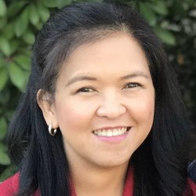
Josephine manages the business and financial activities of CGNET. These include accounting, accounts receivable, accounts payable, payroll, corporate tax, etc. She also manages employees’ medical insurance and retirement benefits.
Josephine has many years of accounting experience, working for Bank of America Savings Bank, the Institute of Primary Health Care, Davao Light & Power Company and the Development Agency Institute, which is a non-profit organization. Josephine speaks fluent English and Tagalog and is a valued member of our team.

Stella Simon Asomugha, IT Consultant & Support Specialist
B.Tech, Computer Science – Modibbo Adama University of Technology, Yola, Nigeria
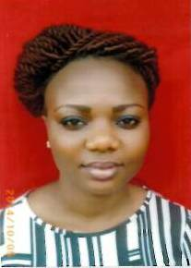
In security, Stella’s experience includes switched network & router security, hardware/software firewalls (ASA/5500 & MS-ISA server), hacking and countermeasures, 802.1x, wireless security, network systems security, patch & vulnerability management, PKI, VPNs, and Cisco IOS Security tools.
Stella’s skills in networking include basic to complex (IGPs & BGP) TCPIP & IPv6 networking, frame-relay, policy-based routing traffic engineering, QoS, multicasting, NAT/PAT, 1700/2500/3600 modular Cisco Routers, L-2 / L-3 switching, stacked / P-VLANs, ether channels, 1900/2900/3500 Cisco switches & APs, HSRP (other IOS features), and WAN Optimization with Riverbed Steelhead Appliances.
Before assuming her role as CGNET Technical Support for the Bill and Melinda Gates Foundation in Abuja, Stella worked for the Infrastructure Concession Regulatory Commission (ICRC) and the Federal Radio Corporation of Nigeria.

Kishore Bhargava, Senior Technology Consultant
B.S., The University of Delhi

Kishore Bhargava is based in New Delhi, India. He has worked with and for CGNET for 20 years. Kishore provides consultancy in the areas of IT Operations, System Administration, Facility Management, Network Administration, Security, System Design, and Training Kishore managed entire IT departments (from 250-1500 users) for CGNET clients in Indonesia, Philippines, and Kenya. He has also provided on-the-ground support to many CGNET clients including Ford Foundation, Packard Foundation, Family Health International (FHI), CARE, Center for International Forestry Research, International Rice Research Institute, International Development Research Center, International Crops Research in Semi-Arid Tropics, International Fund for Agricultural Development and many others. Kishore is an expert contributor to several respected technology magazines and a regular presenter on a Delhi-based technology television program, “Gadget Guru.”

Jacqueline Bilodeau, Communications Director
B.A., Stanford University, Sociology/Social Sciences

Jackie manages CGNET’s external communication streams including website design and content, social media, newsletters, blogs, media campaigns and customer relationship management systems.
Jackie has returned to CGNET last year after serving from 1991-2002 as the Client Support Coordinator, where she acted as a liaison between IT support staff and clients. In her current position, Jackie is responsible for the creation, production and distribution of informational and promotional materials to existing and prospective customers, administration of the CGNET website, writing and editing blogs, and other writing and editorial activities (proposals, service contracts, human resources documents, etc.) as needed.
During her years away from CGNET as a stay-at-home mom, Jackie was very active in volunteer work involving community hunger issues. She served as the co-coordinator of a food pantry, assisting with all daily operations and management. Jackie helped modernize the 30-year-old pantry by setting up its first client database, enabling the generation of client demographics and participation statistics. She managed monthly procurement, delivery and handling of food items from the county food bank and donors, organized student and adult volunteers, wrote grant proposals and oversaw special events.

Liliana Bravo, Senior Systems Engineer
B.S., Systems Engineering, University Nacional del Callao, Peru

Liliana has 16 years’ experience on various Microsoft platforms including AD. She has undertaken a dozen migrations to Office 365 and has worked on very complex AD structures of up to 12,000 people. Prior to CGNET, Liliana worked for nine years as System Administrator of the International Potato Centre in Lima, Peru. Liliana holds Microsoft Certified Professional status in messaging, communications and cloud services.

Daniel Callahan, Vice President, Global Services
M.S. Management, MIT Sloan School of Management
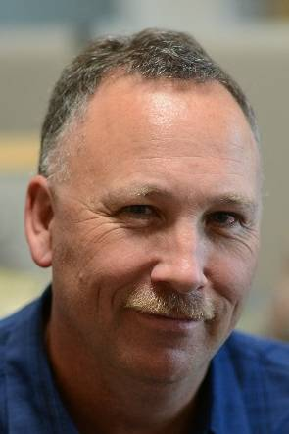
Dan is responsible for development of CGNET’s cloud and security services. He oversees all aspects of CGNET’s Office 365, Skype for Business, Azure, Enterprise Mobility Suite, Dynamics CRM Online, and information security services.
As a consultant, Dan has conducted technology planning, assessment and tool selection projects for customers including the Marin Community Foundation, the Stuart Foundation, Education Pioneers, the California Wellness Foundation, the Houston Endowment, the Annie E. Casey Foundation, ClimateWorks Foundation, the Duke Endowment, Oak Foundation, the Ludwig Institute for Cancer Research and Carnegie Hall.
Dan served as Director of Marketing and Business Operations at CGNET from 1999 to 2003. Prior to rejoining CGNET in 2011, Dan held Director- and VP-level positions in Product Management and Marketing at iPass, SOMA Networks, Daintree Networks (acquired by GE) and YouSendIt (now HighTail). He has been responsible for product lines generating up to $100 million in revenue. Dan has more than 20 years of experience in Product Management, Product Marketing and Software Engineering in the broadband, networking, energy management, mobility and cloud-based services industries. Dan has managed large-scale systems software projects and specified requirements for software supporting millions of concurrent user sessions. Dan’s undergraduate degree is in Anthropology from Stanford University.

Abiy Alemu Eticha, IT Consultant & Support Specialist
B.S., Computer Science, HiLCoE School of Computer Science & Technology
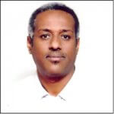
Abiy has been with CGNET for over 6 years, as a consultant on assignment for the Packard Foundation and the Bill & Melinda Gates Foundation. Abiy has been in the IT field for over 12 years and continues to gain valuable knowledge in his field and the certifications and training necessary for him to flourish as an IT Consultant & Support Specialist!

Timothy Haight, Vice President, Technology Services
Ph.D., Communication, Stanford University

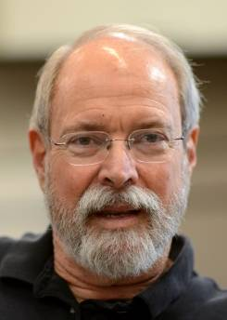
Tim has been studying how nonprofit organizations can optimize their use of information technology for more than 30 years, since he was the first evaluator for Apple Computer’s Community Affairs Program. He has been at CGNET since 2002 and conducted a great number of organizational analyses.
Tim has done assessments and strategic plans for the Marin Community Foundation, Metta Fund, the Houston Endowment, ClimateWorks Foundation, the California Wellness Foundation, the Carnegie Corporation of New York, Bush Foundation, Africa Reinsurance Corporation, Stuart Foundation, Annie E. Casey Foundation, the World Bank (CGIAR), Partners in Population and Development, FAO, the Women’s Funding Network, Britain’s Department for International Development, Canada’s International Development Research Center, the California Healthcare Foundation, the Oregon Community Foundation and the Robert Wood Johnson Foundation.
Prior to CGNET, Tim was Editor-in-Chief of FTPOnline, Vice President of Communications at OneChannel, Executive Editor of Network Computing, and West Coast Bureau Chief of CommunicationsWeek. Early in his career, Tim served on the faculties of the University of Wisconsin-Madison and California State University, Los Angeles. Tim also holds a B.A. from Stanford University.

Richard Hsu, Systems Engineer

B.S., Computer Science with Concentration in Engineering, Cal State Hayward (East Bay)

Richard specializes in network storage, routers, switches and operating systems. At CGNET, he is a part of our engineering team and has major responsibility for our SANs and our VMware infrastructure. Prior to joining CGNET, Richard provided various IT services to Celeros Corporation, the California State Automobile Association and Phillips Semiconductor.

Ehimare Ibazebo, IT Consultant & Support Specialist
B.Eng Computer Engineering, University of Benin, Edo State

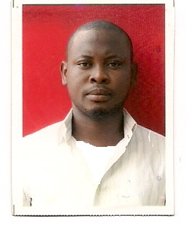
Ehimare’s skills and experience include: providing first and second level IT support; performing daily system monitoring, verifying completion of scheduled jobs such as backups; performing regular security monitoring; IT equipment deployment and support for Cisco IP phones, MFP printers, UPS, laptops, desktops, and domain controllers.
His eight years’ experience includes National Hospital Abuja, Promosol Limited, Setraco Nigeria Limited, Mara-iSON Technologies, and Airtel Nigeria. He is currently a systems engineer at Techspecialist Consulting.

Carol Martinak, Strategic Planning Specialist

BBA, Management Information Systems, CUNY

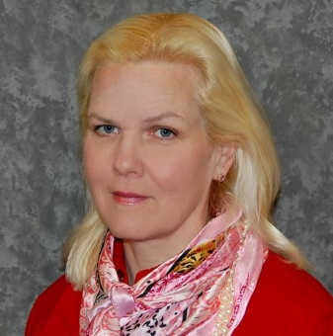
Carol recently rejoined CGNET as a Strategic Planning Specialist. Prior to returning to CGNET, she worked in various capacities for The Access Group for several years, eventually serving as the Vice President of IT. There she crafted and maintained cost-effective leading-edge adoption of new technology for sales force, office staff and network. She previously worked for CGNET from 1998-2004 in the capacity of Global Email Administrator for the Ford Foundation in New York City, one of CGNET’s largest customers.

Georg Lindsey, Chief Executive Officer
Ph.D., Communication, Stanford University

Georg co-founded CGNET in 1983 as a sustainable organization that would keep its clients at the leading edge of practical information and communication technology, with an emphasis on networking, messaging and collaboration. He has overseen and undertaken IT infrastructure designs and installations in Europe, Africa, Asia, North America, South America, and Australia. His on-the-ground experience includes working with scores of international organizations and foundations including Gates Foundation, Ford Foundation, African Development Bank, UNDP, UNEP, World Bank, IFAD, USAID, US Department of Agriculture, and many more.
Prior to CGNET, Georg worked for Nortel Networks’ R & D laboratory, Bell Northern Research. Georg has undertaken consulting assignments for the Rand Corporation, SRI International, NASA, NSF, Los Alamos National Scientific Laboratories, National Institutes of Health, KQED Television, UCLA, UC-Berkeley, University of Southern California, Stanford University, the Food and Drug Administration, and many others. Georg also holds a B.A. and M.A. in Communication from San Jose State University.

Ken Novak, Senior Technology Advisor

B.S., Computer Science, Yale University


Ken has worked for 25 years in the design, implementation, security and performance of wide-area networks. He has also supervised the construction and software architecture of a score of ground-breaking large-scale global databases. Ken was a Reuters Foundation Fellow at Stanford University in 2001-02. Ken’s most recent positions include Chief Architect of Replicate Technologies, a Silicon Valley virtualization startup, and Chief Technology Officer of CGNET Services International.

Dante Palacios, Global Services Manager
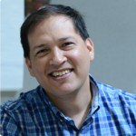
B.S., Computer Science, University of Lima
Dante has supported Microsoft mail products for 11 years and Active Directory since its inception. Dante undertakes client redesigns, upgrades and migrations to advanced platforms such as Office 365, Azure, and AWS. Prior to CGNET he worked for the International Potato Center in Lima. Dante is a VMware Certified Professional, a Microsoft Certified Profession and has undertaken continuing studies at Stanford University. He is fluent in Spanish and English.

Kadir Salami, Senior IT Consultant
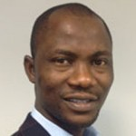
M.S., Information Technology, Ladoke Akintola University of Technology
Salami provides IT management and support to CGNET clients in Africa and Europe. Salami has extensive experience in IT support and development particularly in Nigeria. He heads the consulting firm, Techspecialist Consulting Ltd., and provides system and network administration services to the United Nations Office on Drugs and Crime, the Bill and Melinda Gates Foundation, and Quanteq Technology Services. Salami also hold a B.S. in Engineering from the University of Ilorin.

Jefferson Suarez, Systems Engineer
B.A., Industrial Tech Engineering, San Jose State University
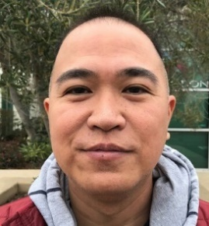
Jefferson has worked in the IT field for over 10 years. He previously worked at Motorola Solutions as a Wireless Test Engineer specializing in enterprise-level mobile and infrastructure Wi-Fi product development. He also worked at Google as a Tier-3 Technical Support agent during their Nexus product launches.

Lonni Ton, Administrative Associate

B.S., Computer Science, Sacred Heart University
Lonni is a leader of CGNET’s 24/7/365 team that is responsible for monitoring, troubleshooting, documenting and escalating any CGNET network-related problems. She also provides project management and advanced technical support, including Open Mobile support. Lonni is also responsible for maintenance and administration of anti-virus, monitoring, documentation, and backup systems. Before joining CGNET, Lonni owned and managed her own business. Before that, she was a network administrator at Microphase Corporation and a PC support technician at Nash Engineering.

Ricardo Uribe, Chief Technology Officer
B.S., Computer Science, Oregon State University

Ricardo has overall responsibility for technology systems, design, implementation and R & D. He is responsible for supporting CGNET clients in fifty countries.
Ricardo has served and currently serves as the virtual Chief Technology Officer at several Silicon Valley startups and foundations including Sonitus Technologies and Metta Fund. He oversees the local IT support of the Bill and Melinda Gates Foundation offices in Beijing, New Delhi, Abuja, Addis Ababa, and Johannesburg.
He has conducted strategic ICT consulting and assessments for the World Conservation Union, Carnegie Corporation, Duke Endowment, University of the Virgin Islands, FAO in Rome, the Africa Rice Center in Cotonou, Benin, the International Institute of Tropical Agriculture in Ibadan, Nigeria, the African Development Bank, the Robert Wood Johnson Foundation, the Annie E Casey Foundation, and many others.
Ricardo joined CGNET in 1999 after working for seven years at the International Center for Tropical Agriculture (CIAT) in Colombia in the GIS department, and later in the Information Systems Unit as Network and Computer Administration Manager, User Support Manager, and Acting Chief Information Officer.

Ana Villarreal, Administrative Assistant
B.S. Systems Engineer, University of Lima

Veronika recently joined CGNET as an Administrative Assistant, working with the A/R and A/P departments as well as providing general clerical duties for the company.
Prior to CGNET, Veronika worked in Sales with Editrade and Oracle, and as an Autodesk Product Manager for Sams. She joins our team after spending several years as a stay-at-home mom and volunteer in her community.

